**ISLAMIAT ASSIGNMENT**

**COURSE: ISLAMIC STUDIES**

**COURSE CODE: HS-205**

**NAME: SYED MUHAMMAD TAIMOOR**

**ROLL NO: CS-031**

**BATCH: 2020**

**SEC: A**

**COURSE TEACHER: DR. ABDUL HAI MADNII MADNI**

**TOPIC: ANALYSIS OF HADITH IN ISLAM**

**DEPARTMENT: COMPUTER AND INFORMATION SYSTEMS(CIS)**

**TABLE OF CONTENTS:**

1) Preface

* IMPORTANCE OF TOPIC
* CHOICE OF TOPIC, WHY?
* POINTS DISCUSSED IN ASSIGNMENT

2) REPORT

* TYPES OF HADITH
* 6 RELEVENT BOOKS OF HADITH
* THE USE OF HADITH IN THE ESTABLISHMENT OF ISLAMIC LAW
* THE PROCESS BY WHICH AHADITH WERE COLLECTED IN THE EARLY CENTURIES OF ISLAM
* THE USE OF HADITH IN THE ESTABLISHMENT OF IJMA
* THE USE OF HADITH IN THE ESTABLISHMENT OF QIYAS
* SOME AHADITS AND THEIR SIGNIFICANCES

3) CONCLUSION

**PREFACE:**

IMPORTANCE OF TOPIC:

**What is Hadith?**

A record of traditions and sayings of Hazrat Muhammadﷺ, his actions, words and his silent approval which constitutes the second major source of religious matters and moral guidance after the Quran.

**What is the importance of Hadith and its analysis in Islam?**

* Hadith is a collection of faith, behavior and teachings of Islam for the guidance of Muslims in the right way.
* Hadith tells us the path to live and act according to behavior of Hazrat Muhammadﷺ and his lifestyle so that we could prosper in our life and choose our better lifestyle.
* Hadith helps Muslims to become much closer to Allah by performing what Allah wants his servants to do and what he wills and prevents from what Allah forbids.
* Hazrat Muhammadﷺ is the role model of Muslims. We can reach to explanations of Quranic texts through Hadith literature.
* It is the source through which the religious sources, doctrines and dogmas can be accessed.

**CHOICE OF TOPIC, WHY?**

This topic “Analysis of Hadith in Islam” is chosen because it is necessary for Muslims to study and analysis Hadith to determine the righteous paths to perform actions like in Namaz, how we should perform prayers and what are the steps to perform ablution before prayer, how we should trade and what are Halal and Haram foods and actions which are forbidden in our religion, and how much gold, silver and how many sheep, camels and cows which can create mis understanding among the followers of Islam are all clearly explained in Hadith and we take help from it in various religious matters.

As we know that after Quran, Hadith is the second most important way to get knowledge. There are many verses of the Quran that cannot be cleared for us because everyone has so many different thinking and views so Hadith in this sense works as an interpreter and explanator which increases the probability and chances of understanding the Quranic verses in the right manner.

After the death of Hazrat Muhammadﷺ, the spiritual meditation ends up and troubles in different religious matters were created and the things were changing, that’s why, we as a Muslims must review the Hadiths from relevant resources for guidance and I chose this topic.

**POINTS DISCUSSED IN ASSIGNMENT:**

There are lots of points discussed in this report:

* First, we have discussed the types of Hadith briefly, on many bases like: sanad, nature, narrators and many others.
* Second, we have discussed about the 6 Relevant books of Hadith, from which you can take guidance and analyze the Ahadith of Hazrat Muhammadﷺ.
* Third, we have discussed about the use of Hadith in the establishment of Islamic law that how it helps us in seeking guidance in many religious matters.
* Fourth, we have discussed about the process how after death of Hazrat Muhammadﷺ Muslims did hard work to collect the Ahadith and secure it in one place for further centuries.
* Fifth, we have discussed about the use of Hadith in Ijma so that with change of era and time, we can take right decisions under the Morals of Islam.
* Sixth, we have discussed about the use of Hadith in Qiyas so that in social and regional matters we can take help from Hadith and do our actions according to orders of Allah.
* At last, we have discussed the several Ahadith and their features.

**REPORT:**

**1) types of hadith:**

**Three basic kinds of Hadith:**

1. Qawli Hadith - what Prophet said and spoke himself.

2. Fi’ali Hadith - The action of Prophet what he performed and demonstrated.

3. Taqriri Hadith - which comes from Prophet silence regarding any action.

**On the basis of sanad:**

1. Marfu’a - Hadith which sanad stretches back to the Prophet.

2. Mawqoof - Hadith which sanad reches to the companion of Prophet.

3. Maqtoo’a - Hadith where student of the companion of the Prophet Tabi’ is the end of the sanad.

**On the basis of strength of narrators:**

1. Mutawatir Hadith - which is reported by such a large number of people that they cannot be expected to agree upon a lie, all of them together.

2. Ahad Hadith - which is narrated by people whose number of narrators does not reach that of the mutawatir.

1. **Mash'hur** - famous: hadith reported by more than two reporters.
2. **Aziz** - rare, strong: at any stage in the isnad, only two reporters are found to narrate the Hadith.
3. **Gharib** - strange: At some stage of the isnad, only one reporter is found relating it.

**Reliability of sanad and matan of the Hadith:**

It is divided into three categories,

1-Sahih

Genuine Hadith that passes all the tests and can be regarded without any question coming from the prophet.

2-Hasan

Strong Hadith but raising some doubt about the authenticity.

3-Daif

Weak Hadith that raise many questions about its authenticity.

**On the basis of nature of words of Hadith:**

There are two kinds of Hadith.

1-Hadith Nabawi - which contains the words that Hazrat Muhammad, spoke himself. For example, Holy Prophet said, “**All actions are judged by intentions”**.

2-Hadith Qudsi - which contains the words from Allah.

For example, when Allah completed creation, He wrote in His book which is with Him above the throne. **“Truly My mercy overcomes My wrath”.**

Every Hadith has two parts.

* The first part consists of a chain of names. This is called the sanad, plural isnad, which means support because it is the authority for the genuineness of the Hadith.

This particular sanad consists of Eight names.

* Muhammad ibn Ismail Bukhari
* Al- Humaydi
* Abdullah ibn Zubayr
* Sufyan
* Yahya ibn Said al Ansari
* Muhammad ibn Ibrahimm al -Taymi
* Alqama ibn Waqas al- Laythi
* Hazrat Umar ibn al –Khattab
* The second part of the Hadith consists of words from Prophet himself. This is called the matan which means, among other things.

For example, Holy Prophet said, **“Modesty brings nothing except goodness”.**

Resource: <https://www.slideshare.net/olycompk/hadith-ranking-type-of-hadith-in-islam>

**2) 6 relevant books of hadith:**

A group of people having special interest spared their lives for collection of accurate Ahadith. Many books were compiled in the early centuries.

**1. Sahih Bukhari:**

Imam al-Bukhari was born in 194 A.H. and he demised in 256 A.H. He scrutinized and selected accurate Ahadith in his book. He maintained the condition of meeting of narrators with one other. He never had more than six persons in his Isnad. This consists of 7 275 Ahadith including those Ahadith which have been repeated. Sahih-ul-Bukhari has earnestly gained the reward of being the most authentic after the Holy Quran. It is one of the six authoritative books of Ahadith.

**2. Sahih Muslim:**

Imam Muslim wrote many books and treatises on Hadith, but the most important of his works is the collection, **Jami**. Imam Muslim took great pains in collecting 300,000 Traditions, and then after a thorough examination of them retained only 4000, the genuineness of which is fully established.Imam Muslim considered only such traditions to be genuine and authentic as had been transmitted to him by an unbroken chain of reliable authorities and were in perfect harmony with what had. It is one of the six authoritative books.

**3- Jami Al Tirmizi:**

This book is compiled by Abu Isa Muhammad ibn Isa Tirmizi. It is one of the six authoritative books of Ahadith.

The Special characteristics of Jami Al Tirmizi are,

1. It is a Sunan and a Jami. 2. Only 83 Ahadith are repeated. 3. Imaam Tirmizi (R.A.) omits the major portion of the Hadith and only mentions that part which is relevant to the heading (title). 4. After mentioning a hadith he classifies it i.e., whether it is authentic or weak, etc. 5. He specifies the narrator’s names, e.g., if the narrators Kunya (honorific name) was mentioned, he would then mention his proper name and vice versa. 6. He never narrated hadith from those who fabricated hadith.

**4. Sunan Abu Dawud:**

This book is compiled by Abu-Dawud Sulaiman bin Al-Aash'ath. His primary interest was in law; hence his collection focuses purely on legal Ahadith. From about 50,000 Ahadith, he selected 4,800 for inclusion in his work based on their superior authenticity. Sunan Abu-Dawud is divided into 41 books on different subjects, each book containing many Ahadith. The numbering system used by Abu-Dawud is consecutive and uninterrupted for the entire collection. It is one of the six authoritative books of Ahadith.

**5. Sunan Al Nisai:**

This book is compiled by Ahmad ibn Ali Al Nisai. It is one of the six authoritative books of Ahadith. Imam Nisai has taken special measures to collect the correct Ahadith.

Resource: <https://www.slideshare.net/olycompk/hadith-ranking-type-of-hadith-in-islam>

**6. Sunan Ibn Majah:**

This book comprises of 32 sub-books, 1,500 chapters and 4,341 narrations (3002 of which have been recorded also by the authors of the other five books). It is of the lowest grade of the six books in its authenticity. However, it is unique in its beautiful arrangement of sub-books and chapters and in containing very little repetition. The author`s name was Abu Abdillah Muhammad ibn Yazid ibn Abdillah ibn Majah al-Rib`i al-Qazwini. He was born in 209 AHS. in Qazvin, a city in Iran, and died in 273 AHS. His travels for study included journeying to Khurasan, Rayy, Iraq, Syria, Hijaz, Egypt and other places. His teachers include Muhammad al-Tanafasi (d. 233 AH.).

Resource: <https://www.askourimam.com/2016/04/06/the-six-authentic-books-of-hadith/>

**3) THE USE OF HADITH IN THE ESTABLISHMENT OF ISLAMIC LAW:**

The word Hadith means news, report or narration. Applied to the life of the Prophet, this term is reserved for the actions and deeds of the Prophet or his tacit approval for any action. Hadith is the second source of Islamic law.

It is said, **“O you who believe Obey Allah and obey the Messenger and those charged with authority among you. If you differ in anything among yourselves Refer it to Allah and His Messenger”** (**Al -Nisa 4.59).**

This establishes the authority of the Hadith as the second source of the Islam. Hadith gives teachings on points about which the Quran has not spoken. The Quran repeatedly asks us: **“Establish regular prayer”** without speaking about the number of rakats and manners in which it should be performed. Hadith of the Prophet explains it.

The Holy Prophet said, **“The Messenger of Allah did not leave offering four rakats before the noon prayer.” [Bukhari]**

This Hadith confirms four rakats for Zuhr prayer. Sunnah of the Prophet provides the explanation of the teachings of the Quran.

The Quran says**, “Allah has permitted trade and forbidden Riba” (2:275).**

Sunnah of the Holy Prophet provides detail of the Riba by saying, The Holy Prophet said.

**“The bartering of gold for gold is Riba, except if it is from hand to hand and equal in amount, and wheat grain for wheat grain is Riba, except if it is from hand to hand and equal in amount”.** Sunnah of the Holy Prophet provides practical methods of Islamic practices.

The Quran enjoins us: **“Pilgrimage thereto is a duty men owe to Allah, those who can afford the journey”.**

Full method of the Hajj is not mentioned in Quran. Sunnah of Prophet explains its performance, as it is said.

Ibn Umar reported**, “The Holy Prophet pronounced Talbiyah in Hajj and Umrah”.** Sunnah of the Prophet becomes basis of Ijma and Qiyas.

It is a fact that the Prophet not only taught but also took the opportunity of putting his teachings into practice in all the important affairs of life.

Resource: https://www.slideshare.net/olycompk/hadith-ranking-type-of-hadith-in-islam

**4) the process by which ahadith were collected in the early centuries of islam:**

History of Hadith compilation can be divided into three ages. They are as follows:

(i) The age of Prophet and his companions (from the advent of Prophet up to the 110 A.H.)

(ii) The age of students of Prophet’s Companions known as ‘Tabieen’ (from 111 A.H. up to 170 A.H.).

(iii) The age of the students of ‘Tabieen’ known as Tabaa Tabieen (from 171 A.H. up to 220 A.H.)

**(i) The age of the Prophet and his Companions:**

The Holy Prophet used to advise his companions to acquire the knowledge of Hadith. Like Quran, companions of the Prophet memorized and wrote traditions of the Prophet with keen interest.

Saheefa-e-Sadiqah was compiled by Hazrat Abdullah s/o Amr. Sahifah-i-Abu Hurairah was compiled by a student of Abu Harairah named Humam s/o Munabbah. Hazrat Saad s/o Ubadah and Jabir s/o Abdullah compiled their own collections individually which were known as the book of Saad and the book of Jabir respectively. Hazrat Ali also compiled a book of Ahadith which is known as Saheefa-i-Ali. It is clear proof of Ahadith in written form during the period of Holy Prophet.

**(ii) The age of Companion’s students known as Tabien (from 111 A.H. upto 170 A.H.):**

Most of the Prophet’s Companions had passed away when the first Hijrah century came to end. Now the responsibility of preservation of Ahadith lay on the shoulders of the companion’s students commonly known as ‘Tabieen’ in Muslim history. During the reign of Hazrat Umer s/o Abdul Aziz as Caliph, he sent a circular in all the cities of Muslim Empire requesting theologians to collect and compile Ahadith from wherever they could find them. In compliance with the directions of Caliph Omer s/o Abdul Aziz, theologians became active to collect and preserve Ahadith. They searched every nook and cranny of the Muslim World in search of Ahadith. The following three scholars did noteworthy work in the field of Ahadith collection in that period.

**1) Imam Shaabi –** He collected and compiled Ahadith in Kufa.

**2) Imam Makhool –** He did a scholarly work in this field in Syria.

**3) Imam Zuhri –** He accomplished his research work in the field of Ahadith in Madinah.

The following books were compiled during this age:

**1) Kitab-ul-Aathar –** Compiled by Imam Abu Hanifah

**2) Moatta Imam Malik –** Compiled by Imam Malik s/o Anas

**3) Jam’e Sufyan Thauri –** Compiled by Sufyan Thauri.

**(iii) The age of students of Tabieen (students of companions) Known as ‘Tabaa Tabieen (from 171 A.H. upto 220 A.H.):**

The third century of Hijrah calendar is known as the age of Tabaa Tabieen. This age is known as the age of climax of the knowledge of Hadith. During this Lunar century, the Muslim Scholars went to every nook and cranny of the Muslim world to collect Ahadith and other relevant information related to the subject.

Arrangements were made to check the accuracy of Ahadith. A criterion was fixed to test reliability of Ahadith’s narrators. The science of critical examination known as ‘Jirh-o- Taadeel’ and “Asma-ur-Rijal” was established. Six authentic books of Ahadith known as Sihah- i-Sittah were compiled by research scholars of the Muslim world. The names of those collections with the names of their compilers are as under:

**1. Sahee Bukhari –** It was compiled by Abu Abdullah Muhammad s/o Ismael Bokhari.

**2. Sahee Muslim –** It was compiled by Muslim s/o Hajjaj.

**3. Jam’e Tirmidhi –** It was compiled by Abu Isa Muhammad s/o Isa.

**4. Sunan Abu Dawud –** It was compiled by Abu Dawud Suleman s/o Ashath.

**5. Sunan An-Nasai –** It was compiled by Abu Abdur Rehman Ahmed s/o Ali An-Nasi.

**6. Sunan Ibn Majah –** It was compiled by Abu Abdullah Muhammad s/o Yazid Ibn Majah.

Resource: <https://www.slideshare.net/olycompk/hadith-ranking-type-of-hadith-in-islam>

**5) THE USE OF HADITH IN THE ESTABLISHMENT OF ijma:**

Ijma is the third source of Islamic Law. It means, “agreeing upon” or “uniting in opinion”. It is the unanimous agreement of the Islamic Community on some aspect of law.

For the support of Ijma, the Holy Prophet said,

**“Gather together the righteous from among my community and decide the matter by their counsel…”** and Holy Prophet said**,**

**“My community will never agree upon an error”.**

These references indicate that Hadith allow the use of Ijma. It has been accepted that agreed view of the community is binding upon Muslims in legal.

Decision of Prophet based on Ijma is,

• At the time of Uhd encounter, Holy Prophet decided to leave the town to meet the enemy rather than to stay at Madinah because the opted decision was the unanimous decision of his companions. This example shows that how Prophet himself practiced Ijma.

Resource: <https://www.slideshare.net/olycompk/hadith-ranking-type-of-hadith-in-islam>

**6) THE USE OF HADITH IN THE ESTABLISHMENT OF qiyas:**

Qiyas literally means measuring or ascertaining the length, weight or quality of something. Qiyas means essentially to use human reasoning to compare an existing situation with one for which legislation already exists. Qiyas is comparison to establish equality or similarity between two things.

Qiyas is the most important method of Ijtihad. It cannot be exercised against any “Nas” of Quran and Sunnah.

Qiyas is exercised with the help of these four pillars,

**Asl**: the fundamental teaching

**Far**: the new matter in question

**Illah**: the linking cause that connects them

**Hukm**: new judgment

**Examples of Qiyas exercised by Prophet:**

Once a woman came to the Prophet and stated that her mother (in some traditions her sister), who had solemnly declared to perform Hajj, had died before doing so. She asked if it was necessary to perform Hajj on her mother’s behalf. The Prophet paused for a while & then said, “Verify what would you do if she had left debts repayable. Naturally you would pay.” Here the ‘Illa’ or effective cause in both cases is the fulfillment of obligations.

Another example of Qiyas is as follows:

There was also the incident at the signing of treaty of Hudaybiya, when at the insistence of the representative of the Makkans, he Prophet Muhammad asked Hazrat Ali to change his name from Muhammad, the prophet of Allah, to Muhammad ibn Abdulah. Hazrat Ali, however did not obey out of respect of dignity. Hazrat Muhammad did not make any objection to this exercise of his personal judgement.

**Conditions of Qiyas:**

There are necessary conditions for Qiyas. Qiyas must be according to basic principles of Quran and Hadith. The aim of Qiyas is not to alter any Quranic or Sunnah law or text (Nas). Moreover, it should be understandable for the Ummah. Its reasoning should be easily comprehended by human intellect. Qiyas is redundant where Nass is there.

Resource: <https://www.slideshare.net/olycompk/hadith-ranking-type-of-hadith-in-islam>

**7) SOME AHADITS AND THEIR SIGNIFICANCES:**

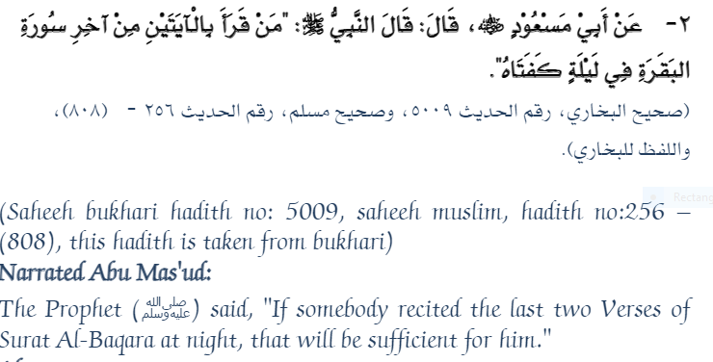

**Some of the benefits of this Hadith:**

1.Whoever recites these verses of Surat al-Baqarah at night, Allah will

bestow the blessing and saves him from evil.

2. Whoever recites these verses his Belief in Allah becomes firm.

3. Whoever recites these two verses with pure heart with good intention it is good for him, he can recite them anywhere anytime.

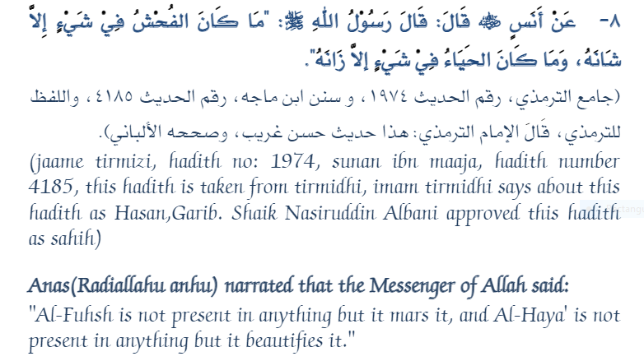

**Some of the benefits of this Hadith:**

1. According to Islam, Modesty is very good quality, every Muslim man

and women should have this grate quality.

2. Modesty drives a person towards loyalty and obedience and keep

away from evil.

3. Not only are you respecting yourself when you dress with dignity, but others respect you, too. 67% of guys ages 18-22 when polled said they felt uncomfortable when speaking to a woman dressed immodestly, and all of them from another survey said they had more respect for girls who respected themselves with their clothing choices.

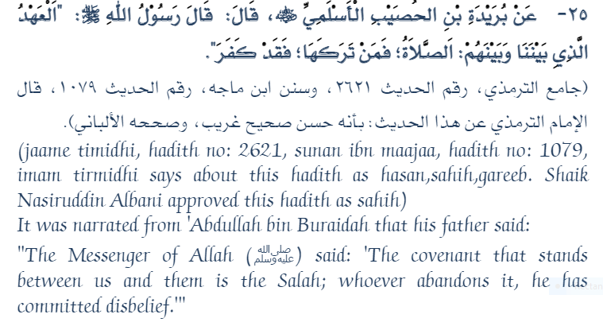

**Some of the benefits of this Hadith:**

1.In this Hadith, the significance of prayer (Salah) is defined.

2. In Islam, the difference between Muslim and non-Muslim is not performing prayers (daily five times obligatory prayers).

3. This hadith teaches u to be careful in offering Salah prayers (daily five times obligatory prayers) and must not neglect it.

4. In Islam, Salah is like a “Soul” in the body, whoever leaves it he loses

relation with Islam.

5. Through Salah one can sought the help of Allah to overcome the problems/challenges one faces.

6. Allah says in Quran: **“And seek help through patience and prayer, and indeed, it is difficult except for the humbly submissive**

**(to Allah).”**

7.In tough conditions, Prophet Muhammad (peace be upon him) use to perform Salah.

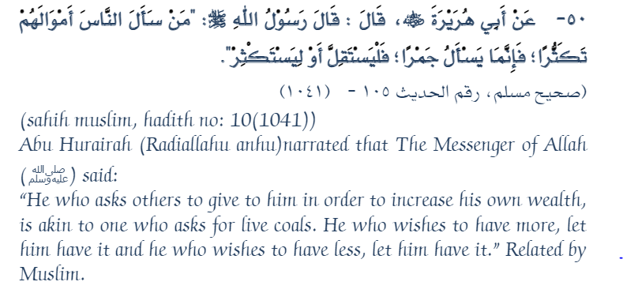

**Some of the benefits of this Hadith:**

1. This Hadith gives the importance of hard work.

2. Begging money for silly needs in all its forms is prohibited by our prophet (peace be up on him), this is also treated as a sin and can earn anger of Allah.

3. A person has to fulfill his personal needs on his own without depending on others, if one practices depending on others will never be fulfilled, but if one who believe in his lord and works hard, Almighty Allah will bestow his blessings to him.

4. By performing hard work,it is an example to our kids.

5. There is never any short cuts to success, but hardwork complimented with the desire to achieve, determination, and always being motivated to get after your goal, it makes success becomes bigger.

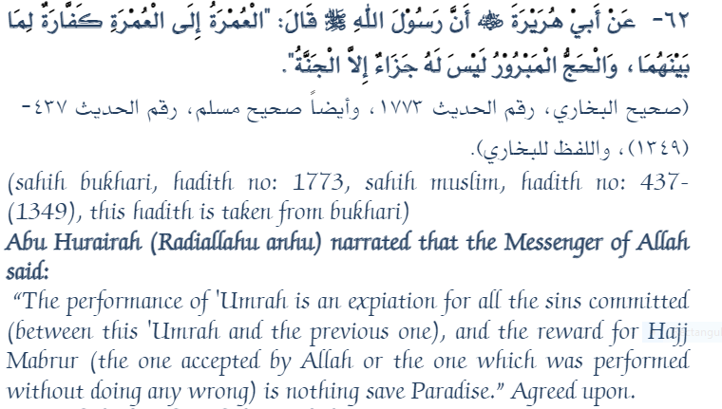

**Some of the benefits of this Hadith:**

1. This Hadith encourages us to frequently perform umrah, as sins occurred between two umrahs will be wiped off. It is mentioned that minor sins only be forgiven, but for major sins to be forgiven we have too truly repent.

2. Haj-e-Mabroor means the Hajj which is accepted by Allah. For Hajj to be acceptable it has to be to please Allah alone and to be performed strictly as per the conditions prescribed in Qur’an and Sunnah (to follow

prophet’s way of performing). Paradise is the reward for accepted Hajj by Allah.

3. This Hadith explains us the importance of Hajj and Umrah. Allah forgives all minor sins occurred between two Umrahs performed and

Paradise is the reward for accepted Hajj by Allah.

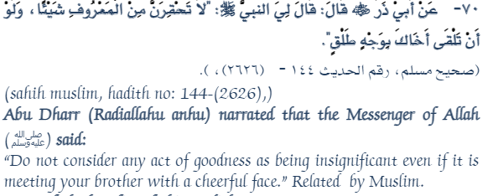

**Some of the benefits of this Hadith:**

1. This Hadith teaches us to meet our fellow beings with smiley face

2. We have to treat people with love, affection and behave with best manners.

3. This is the true face of Islam. Islam teaches us to spread love and brotherhood to the world and make the world peaceful with your actions and kindness.

**Conclusion:**

From this assignment, we have concluded many important topics about Hadith, its types, its books, hardships and carefulness in copying down every Hadith, its uses in our Islamic life, and other regional matters.

Life of Hazrat Muhammadﷺ is our role model that how we can seek guidance and live our life according to order of Allah. Hazrat Muhammad’s ﷺ every action and sayings are beneficial for us. So, in matters of Salah, Hajj, Roza (Fast), Zakat, Ablution, Rights of Women, Children, Old people, Animals, Poor people, Non-Muslims and many others rights, and many other social, personal and religious matters, after Quran we can take guidance from Ahadith.